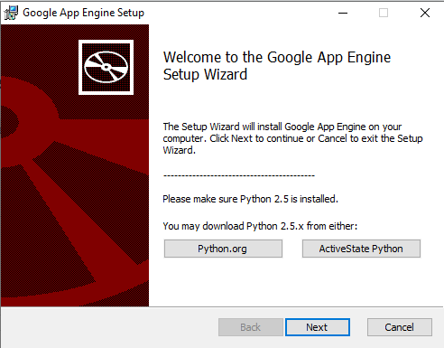
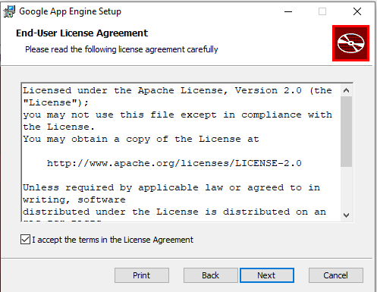
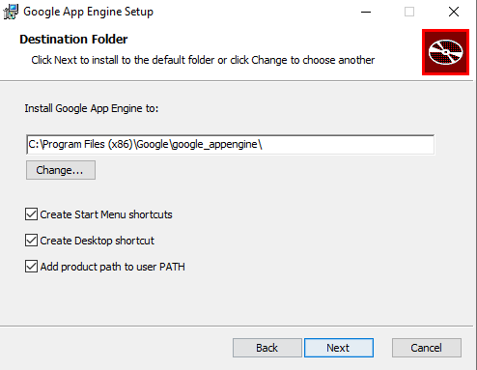
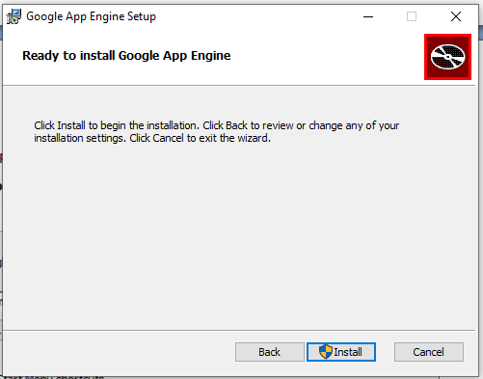
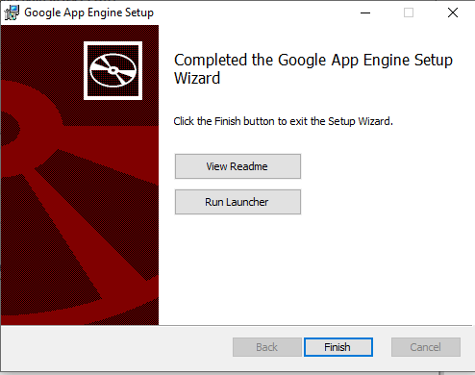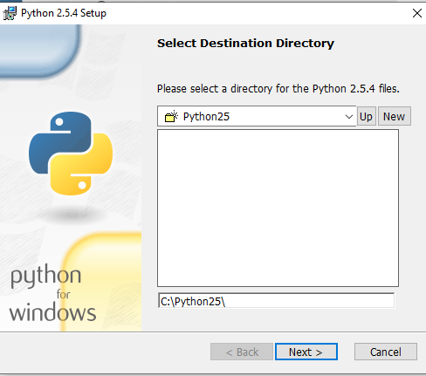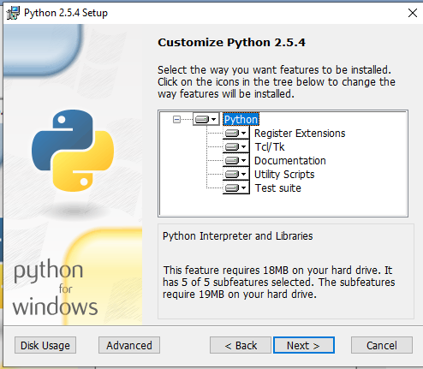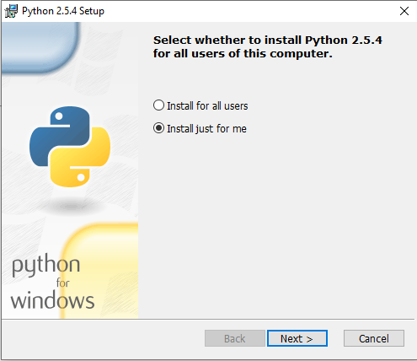
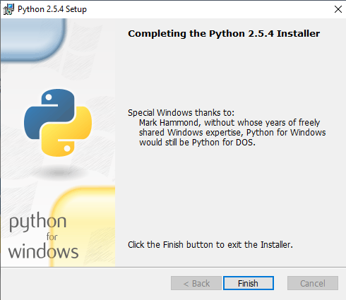
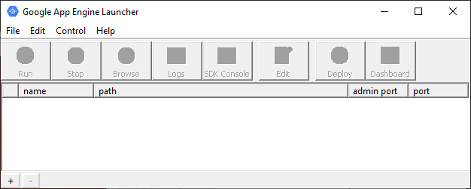
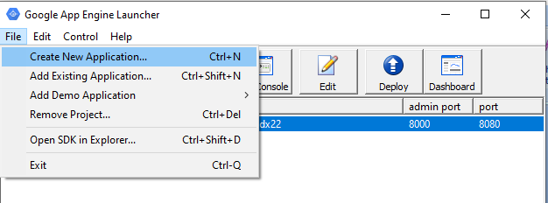
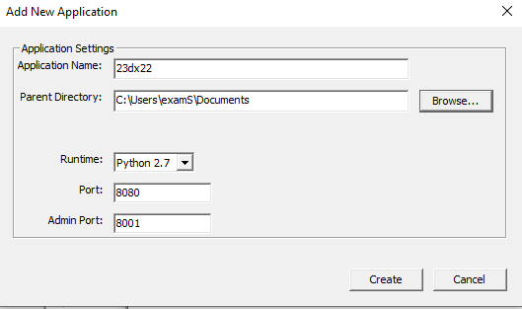
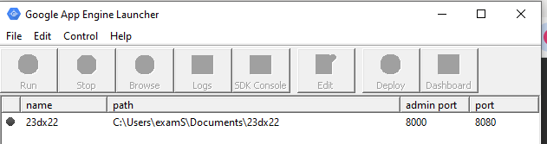
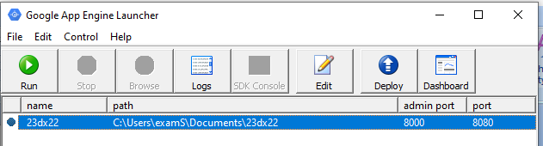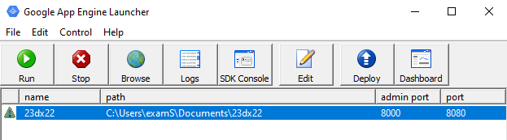
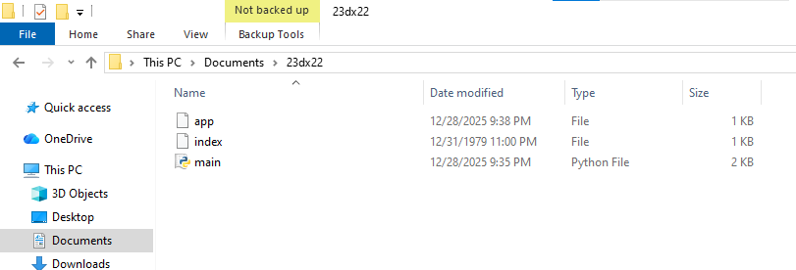
app.yaml
application: 23dx22
version: 1
runtime: python
api_version: 1
handlers:
- url: /.*
script: main.py

main.py

#!/usr/bin/env python

from google.appengine.ext import webapp
from google.appengine.ext.webapp import util

class MainHandler(webapp.RequestHandler):
def get(self):
self.response.out.write("""
<html>
<head>
<title>About Me</title>
</head>
<body>
<h1>About Me</h1>

<p>
My name is krithiya and I am a student who enjoys learning new technologies.
I am interested in understanding how software applications are designed and
executed on the web. By working with Python and the Flask framework, I am
gaining practical exposure to web servers and application development.
This project helps me strengthen my technical skills and confidence in programming.
</p>

</body>
</html>
""")

def main():
application = webapp.WSGIApplication(
[('/', MainHandler)],
debug=True
)
util.run_wsgi_app(application)

if __name__ == '__main__':
main()
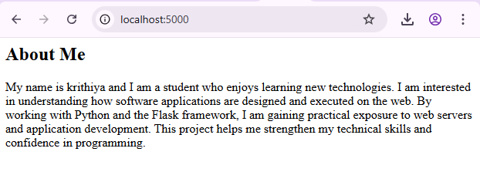













app.yaml
application: 23dx22
version: 1
runtime: python
api_version: 1
handlers:
- url: /.*
script: main.py

main.py

#!/usr/bin/env python

from google.appengine.ext import webapp
from google.appengine.ext.webapp import util

class MainHandler(webapp.RequestHandler):
def get(self):
self.response.out.write("""
<html>
<head>
<title>About Me</title>
</head>
<body>
<h1>About Me</h1>

<p>
My name is krithiya and I am a student who enjoys learning new technologies.
I am interested in understanding how software applications are designed and
executed on the web. By working with Python and the Flask framework, I am
gaining practical exposure to web servers and application development.
This project helps me strengthen my technical skills and confidence in programming.
</p>

</body>
</html>
""")

def main():
application = webapp.WSGIApplication(
[('/', MainHandler)],
debug=True
)
util.run_wsgi_app(application)

if __name__ == '__main__':
main()


